**GROUP 9**

**EXPERIMENT 9A**

**AIM: DATA PUBLISH IN UBIDOTS USING MQTT PROTOCOL LM35**

**Block Diagram:**

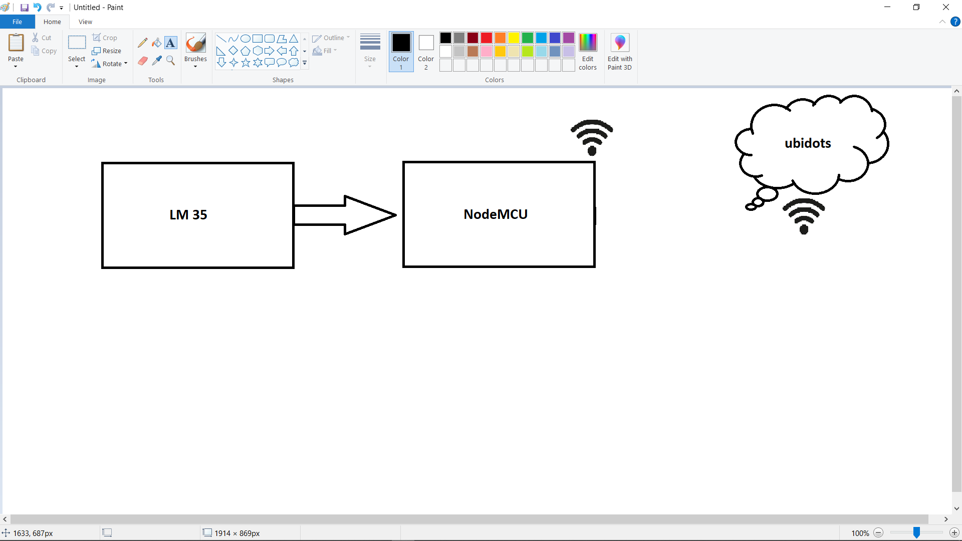

**MQTT**

**Fig: 1a**

**Explanation of block diagram:**

Here, we are sensing the temperature using LM35 analog sensor. Then by connecting the LM35 sensor with NodeMcu, we are sending that sensed temperature value to the ubidots cloud server using MQTT protocol. In this last step we are taking the help of NodeMcuwifi module. By the help of ESP8266 wi-fi module, the NodeMcu is being connected with the ubidots cloud server and is publishing the sensed value.

**Apparatus:**

* LM35 Sensor
* NodeMCU ESP8266 Wi-Fi Module
* Breadboard
* Jumper Wire

**CODE:**

#include <ESP8266WiFi.h>;

#include <WiFiClient.h>;

#include "UbidotsESPMQTT.h"

int val;

int tempPin = A0;

/****************************************

* Define Instances and Constants

****************************************/

#define TOKEN " BBFF-XJNKbcuknuXnr7vWDdkmVY5EPdJ8Po" // Your Ubidots TOKEN

#define WIFINAME "Codermaker" //Your SSID

#define WIFIPASS "babi1pal" // Your Wifi Pass

Ubidots client(TOKEN);

void callback(char* topic, byte* payload, unsigned int length) {

Serial.print("Message arrived [");

Serial.print(topic);

Serial.print("] ");

for (int i=0;i<length;i++) {

Serial.print((char)payload[i]);

}

Serial.println();

}

/****************************************

* Main Functions

****************************************/

void setup() {

client.setDebug(true); // Pass a true or false bool value to activate debug messages

Serial.begin(115200);

client.wifiConnection(WIFINAME, WIFIPASS);

client.begin(callback); }

void loop() {

// put your main code here, to run repeatedly:

if(!client.connected()){

client.reconnect();

}

val = analogRead(tempPin);

float mv = ( val / 1024.0) * 3300;

float cel = mv / 10;

//float value1 = analogRead(A0);

client.add("abcd", cel);

client.ubidotsPublish("dravida");

client.loop();

}

**OUTPUT:**

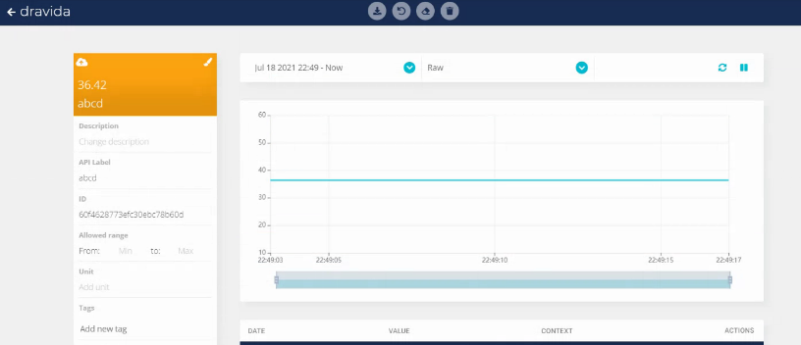

**Fig 1b**

**EXPERIMENT 9B**

**AIM:DATA SUBSCRIBE IN UBIDOTS USING MQTT PROTOCOL LM35**

**Block Diagram:**

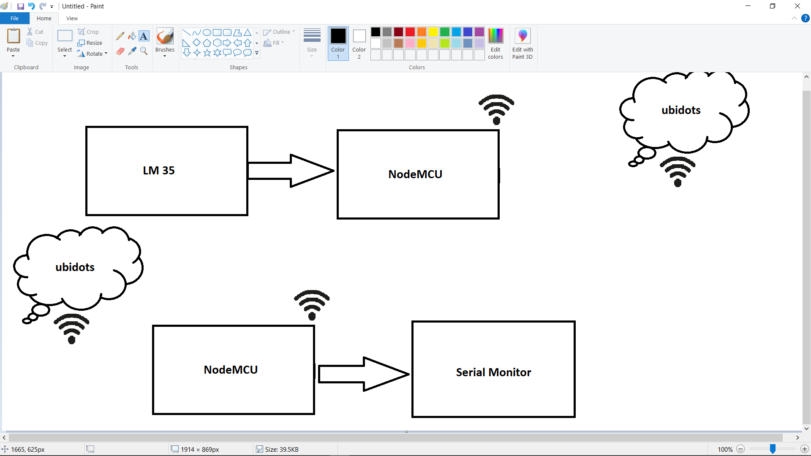

**MQTT**

**Fig: 2a**

**Explanation of block diagram:**

Here, we are subscribing the last uploaded data to ubidots cloud server. By the help of ESP8266 wi-fi module, the NodeMcu is being connected with theubidots cloud server using MQTT protocol and is subscribing the last uploaded data to the mentioned variable of the mentioned device.

**Apparatus:**

* NodeMCU ESP8266 Wi-Fi Module

**CODE:**

#include "UbidotsESPMQTT.h"

/****************************************

* Define Constants

****************************************/

#define TOKEN "**BBFF-XJNKbcuknuXnr7vWDdkmVY5EPdJ8Po** "

#define WIFINAME "Codermaker" //Your SSID

#define WIFIPASS "babi1pal" // Your Wifi Pass

#define DEVICE_LABEL "dravida" // Put here your Ubidots device label

#define VARIABLE_LABEL "abcd" // Put here your Ubidots variable label

Ubidots client(TOKEN);

/****************************************

* Auxiliar Functions

****************************************/

void callback(char* topic, byte* payload, unsigned int length) {

Serial.print("Message arrived [");

Serial.print(topic);

Serial.print("] ");

for (int i=0;i<length;i++) {

Serial.print((char)payload[i]);

}

Serial.println();

}

/****************************************

* Main Functions

****************************************/

void setup() {

// put your setup code here, to run once:

client.ubidotsSetBroker("industrial.api.ubidots.com"); // Sets the broker properly for

client.setDebug(false); // Pass a true or false bool value to activate debug messages

Serial.begin(115200);

client.wifiConnection(WIFINAME, WIFIPASS);

client.begin(callback);

client.ubidotsSubscribe(DEVICE_LABEL, VARIABLE_LABEL); //Insert the dataSource and Var

}

void loop() {

// put your main code here, to run repeatedly:

if(!client.connected()){

client.reconnect();

//Insert the dataSource and

}client.ubidotsSubscribe(DEVICE_LABEL, VARIABLE_LABEL);

client.loop();

}

**OUTPUT:**

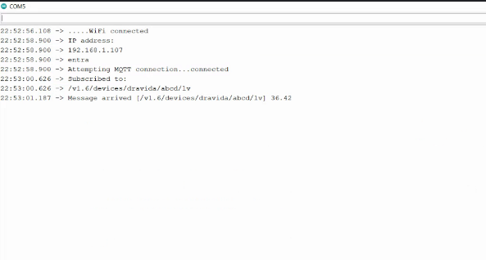

**Fig:2b**